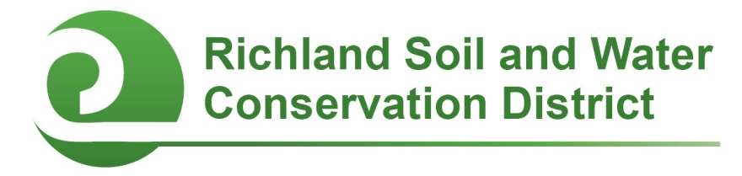
2018 Conservation Scholarship

Criteria and Eligibility:
A $1,000 scholarship is available to one conservation-minded Richland County student who plans to pursue undergraduate studies related to natural resource conservation, sustainable agriculture, or the environment at a college, university, or technical school in South Carolina. The scholarship will be paid to the student’s academic institution upon admission.

- Applicants must be Richland County residents OR attend school in Richland County.
- Applicants must be high school seniors in the 2017-2018 school year.
- Applicants must have a demonstrated interest in natural resources, conservation, sustainable agriculture, and/or the environment and plan to pursue a related career.
- Interested applicants should submit the application form below, a letter of recommendation, a high school transcript, and a personal essay of at least 500 but no more than 1,000 words (described below).
- Applications must be postmarked or received electronically by February 2, 2018.

Basic Student Information:

Applicant’s name:

Phone: Alternate phone:

Address:

City: State: Zip:

Name(s) of parent(s)/guardian(s)

High school:

Expected date of graduation: Current GPA:

College plans (school and major):

Awards and honors:

Extracurricular activities (clubs, sports, community involvement, etc.):

____________________________________________________________________________

Personal Essay (500-1,000 words; please respond on a separate page):
This is your opportunity to describe your passion for conservation, showcase your involvement in conservation and natural resource activities, and discuss your future career plans. How did you become interested in conservation? What does conservation, ecology, or resource management mean to you? What clubs, events or hobbies are you engaged in that demonstrate your interest in conservation? How do you plan to pursue your passion for conservation, natural resources, sustainable agriculture, and/or the environment in college and beyond? What environmental problems have you worked to remedy in the past, or what issues do you hope to address in your future career?

You can use these questions to frame your essay, or think of your own topics. Be sure to address:
- Your interest in conservation, natural resources, sustainable agriculture, and/or the environment.
- Your experiences with conservation/natural resources in high school – e.g., did you join the school ecology club? Participate in Envirothon? Call your government officials about environmental concerns? Do you spend time camping, hunting, hiking, fishing, gardening, farming, etc.?
- Your academic and career goals, and how this scholarship will help you achieve them.

Application must include:

- Basic Student Information (Page 1)

- Personal Essay (described above)

- One letter of recommendation from a teacher or community member who is familiar with your academic achievements, community involvement, and commitment to natural resources and conservation.

- A copy of your most recent high school transcript.

Send application, essay, letter of recommendation, and transcript to:

Richland Soil and Water Conservation District
2020 Hampton Street, Room 3063A
Columbia, SC 29204
Fax: (803) 576-2088
E-mail: cooperc@rcgov.us
Phone: (803) 576-2080

Application packets must be postmarked or submitted electronically by February 2, 2018. Questions? Contact Chanda Cooper at 803-576-2080 or cooperc@rcgov.us.

